**KABOJJA JUNIOR SCHOOL**

MID OF TERM I EXAMS 2024

BABY CLASS

HEALTH habits

**My name is……………………………………………………**

**SCHOOL …………………………………………..……………**

1. **Colour our fruits.**

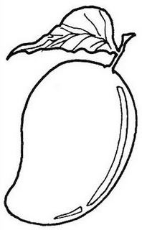 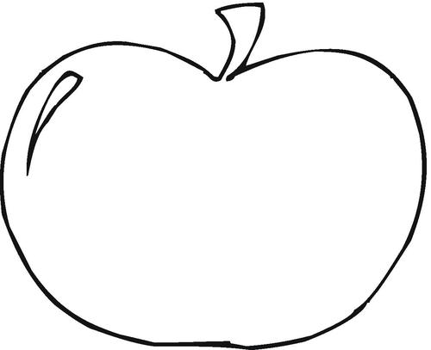

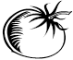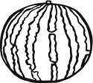

1. **Match the same picture**

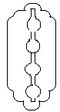

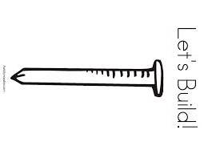



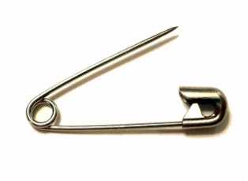







1. **Colour the things we wear**

 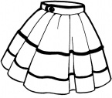

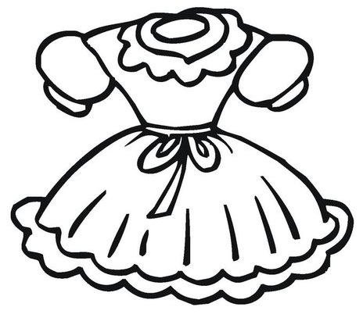 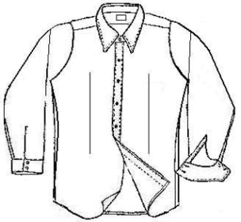

1. **Match the same fruit**

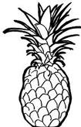 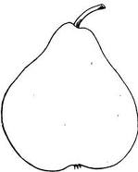

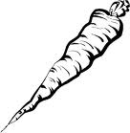 

 

**KABOJJA JUNIOR SCHOOL**

**MID OF TERM I EXAMS 2024**

**BABY CLASS**

**NUMBERS**

My name is……………………………………………………

SCHOOL …………………………………………..……………

1. **Copy and write 1 and 2**

|  |  |
| --- | --- |
|  |  |
|  |  |

1. **Trace number 2**
2. **Shade number 1**
3. Match the same shapes

**KABOJJA JUNIOR SCHOOL**

**MID OF TERM I EXAMS 2024**

**BABY CLASS**

**LANGUAGE DEVELOPMENT**

**My name is……………………………………………………**

**SCHOOL …………………………………………..……………**

1. Shade sound ‘’a’’

1. Trace letter ‘’b’’
2. Shade a ball
3. Copy and write sound ‘’a’’

|  |  |  |
| --- | --- | --- |
| a | a | a |
|  |  |  |
|  |  |  |
|  |  |  |

**KABOJJA JUNIOR SCHOOL**

**MID OF TERM I EXAMS 2024**

**BABY CLASS**

**WRITING**

Name: ______________________________________

School ______________________________________

1. **Copy and write letter ‘’** ‘’

__________________________________________

__________________________________________

__________________________________________

__________________________________________

__________________________________________

__________________________________________

__________________________________________

__________________________________________

__________________________________________

__________________________________________

__________________________________________

1. Copy and write

_________________________________________

__________________________________________

__________________________________________

__________________________________________

__________________________________________

__________________________________________

__________________________________________

__________________________________________

__________________________________________

__________________________________________

__________________________________________

__________________________________________

__________________________________________

__________________________________________

__________________________________________